

**Tribhuvan University**

**Institute of Engineering**

**Purwanchal Campus, Dharan**

**C-Programming Lab Report**

Prepared by:- Nigam Yadav

**LAB SHEET NO.5[To be familiar with LOOPS]**

1.WAP to read 10 numbers from user and find their sum and average.

**Code:**

#include<stdio.h>

int main()

{

int num[10];

int i,sum=0,avg;

printf("Enter any 10 number:");

for(i=0;i<=9;i++)

{

scanf("%d",&num[i]);

}

for(i=0;i<=9;i++)

{

sum = sum + num[i];

}

printf("%d\n",sum);

avg=sum/10;

printf("%d",avg);

return 0;

}

Output:

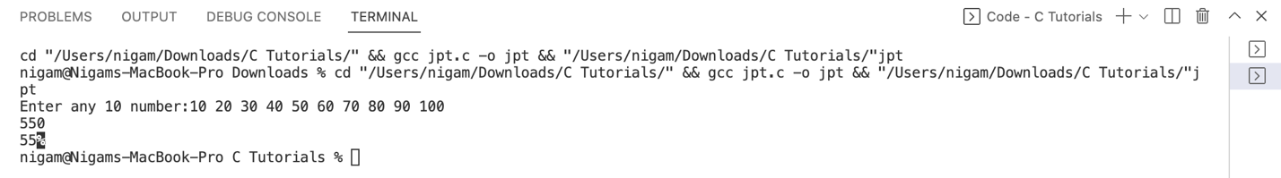

2.WAP to display the multiplication table of integer given by the user.

**Code:**

#include<stdio.h>

int main()

{

int a,i,table;

printf("Enter a number:");

scanf("%d",&a);

for(i=1;i<=10;i++)

{

table = a * i;

printf("%d*%d=%d\n",a,i,table);

}

return 0;

}

Output:

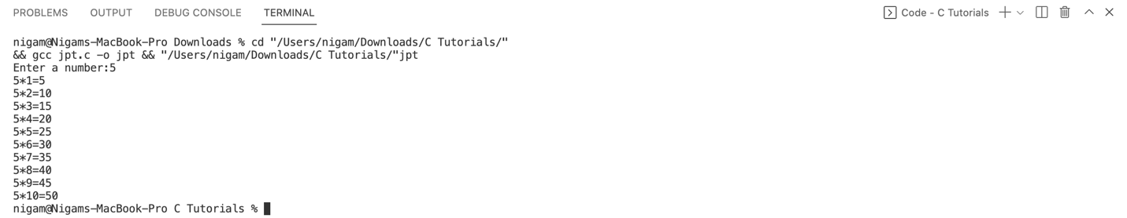

3.WAP to input two integer values from the user and print the even number between the range of integers. Also count the even number and display the count as well [Hint: if user enters 10 and 100. The program should print and count even numbers between 10 and 100].

**Code:**

#include<stdio.h>

int main()

{

int a,b;

int count=0,even,i,temp;

printf("Enter any two numbers:");

scanf("%d%d",&a,&b);

for(i=a;i<=b;i++)

{

if((even=i%2)==0)

{

count = count + 1;

printf("the even number is %d\n",i);

}

}

printf("the total even number is %d", count);

return 0;

}

Output:

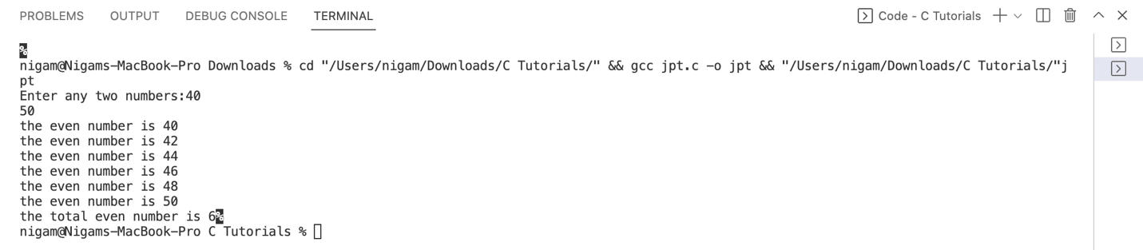

4.WAP to display sum of series: 1 + 1/2 + 1/3 + 1/4 + 1/5 ... 1/n

**Code:**

#include<stdio.h>

int main()

{

float n,i,series=0;

printf("Enter the value of n:");

scanf("%f",&n);

for(i=1;i<=n;i++)

{

series =(1/i)+series;

}

printf("the sum of series is: %f",series);

return 0;

}

Output:

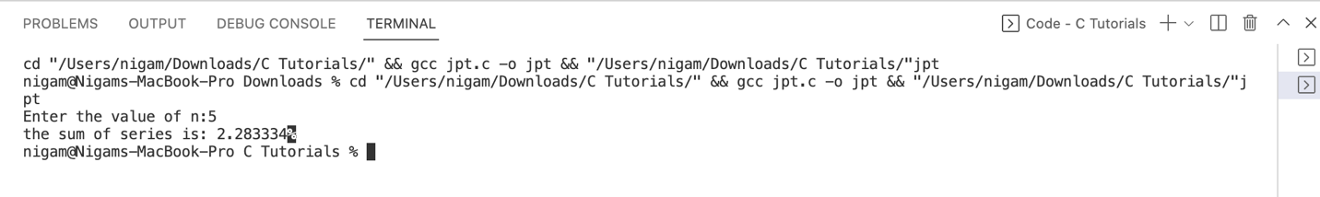

5. WAP to display sum of series: 1 + 1/2! + 1/3! + 1/4! + 1/5! ... 1/n!

**Code:**

#include<stdio.h>

int main()

{

int i,j;

float n, sum=0.0;

printf("enter the value of n :");

scanf("%f",&n);

for(i=1;i<=n;i++)

{

float fact=1;

for(j=1;j<=i;j++)

{

fact=fact*j;

}

sum=sum+(float)1/fact;

}

printf("the sum of the series is %f",sum);

return 0;

}

Output:

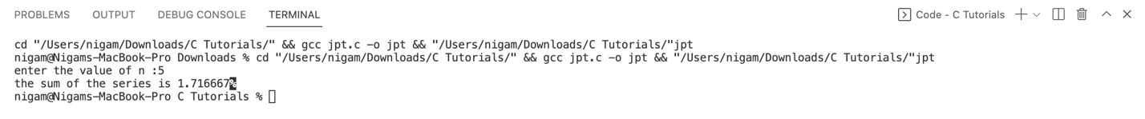

6.WAP to display sum of series: x + x2/2! + x3/3! + x4/4! + x5/5! ... xn/n!

**Code:**

#include<stdio.h>

#include<math.h>

int main()

{

int n,i,j,temp,k;

float sum=0;

printf("enter the value of x:");

scanf("%d",&n);

for (i=1;i<=n;i++)

{

float fact=1;

for(k=1;k<=i;k++)

{

fact=fact*k;

}

sum=sum+ (float)pow(n,i)/fact;

}

printf("the sum of the seires is %f",sum);

return 0;

}

Output:



7.WAP to find the value cos(x) without using cos(x) library function.

**Code:**

#include<stdio.h>

#include<math.h>

int factorial (int n)

{

int i,fact=1;

for(i=1;i<=n;i++)

{

fact=fact*i;

}

return fact;

}

int main ()

{

float x,sum=0.0,count;

int i,n,sign=-1;

printf("enter the value of x:");

scanf("%f",&x);

printf("enter the value of n:");

scanf("%d",&n);

count=x;

x=x*(3.1415/180);

for (i=0;i<=n;i+=2)//i+=2 means i=i+2

{

sign=sign*-1;

sum=sum+sign*pow(x,i)/factorial(i);

}

printf("the value of cos(%.2f)=%2f",count,sum);

return 0;

}

Output:

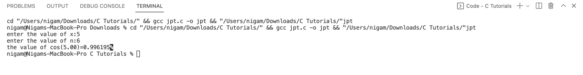

8.WAP to display whether a number is Armstrong or not.

**Code:**

#include<stdio.h>

int main() {

int n,rem,sum=0,flag;

printf("enter a number :");

scanf("%d",&n);

flag=n;

while(n!=0)

{

rem=n%10;

sum=sum+rem*rem*rem;

n=n/10;

}

if(sum==flag)

{

printf("number is Armstrong");

}

else {

printf("number is not Armstrong");

}

return 0;

}

Output:

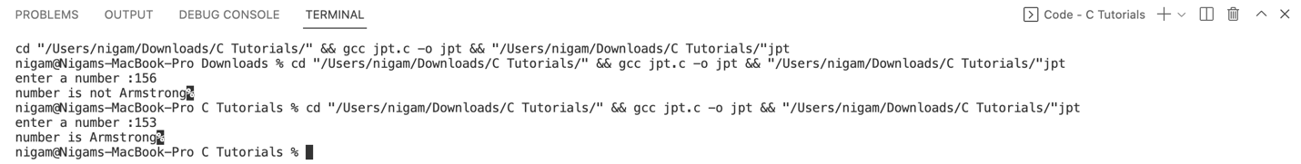

9.WAP to display the terms of Fibonacci series.

**Code:**

#include<stdio.h>

int main()

{

int n,i,first=0,second=1,fact;

printf("enter the value upto which you want fibonacci series:");

scanf("%d",&n);

printf(" %5d %5d",first,second);

for(i=3;i<=n;i++)

{

fact=first+second;

printf("%5d",fact);

first=second;

second=fact;

}

return 0;

}

Output:

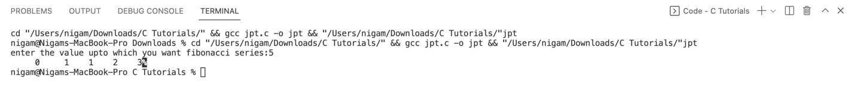

10.WAP to display the number in reverse order

**Code:**

#include<stdio.h>

int main()

{

int num,i,div,scale=0;

printf("enter the number for which you want reverse:");

scanf("%d",&num);

while(num!=0)

{

div=num%10;

scale=scale*10+div;

num= num/10;

}

printf("the reverse of a number is %d",scale);

return 0;

}

Output:



11.WAP to check whether a number is palindrome or not.

**Code:**

#include<stdio.h>

int main()

{

int num,i,div,scale=0,put;

printf("enter the number to check whether its palindrome or not :");

scanf("%d",&num);

put=num;

while(num!=0)

{

div=num%10;

scale=scale*10+div;

num= num/10;

}

if (scale==put){

printf("it is a palindrome");

}

else{

printf("it is not a palindrome");

}

return 0;

}

Output:

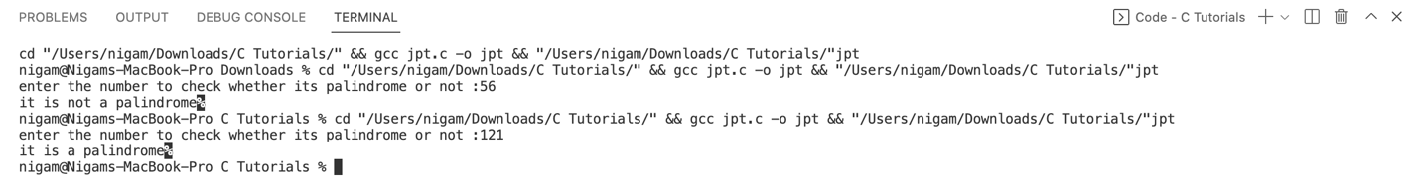

12.WAP to find HCF and LCM of two number.

**Code:**

#include <stdio.h>

int main()

{

int i, n1, n2, j, hcf=1,lcm;

printf("\n\n LCM of two numbers:\n ");

printf("----------------------\n");

printf("Input 1st number : ");

scanf("%d", &n1);

printf("Input 2nd number: ");

scanf("%d", &n2);

j = (n1<n2) ? n1 : n2;

for(i=1; i<=j; i++)

{

if(n1%i==0 && n2%i==0)

{

hcf = i;

}

}

lcm=(n1*n2)/hcf;

printf("\nThe LCM of %d and %d is : %d\n\n", n1, n2, lcm);

printf("\nThe HCF of %d and %d is : %d\n\n", n1, n2, hcf);

return 0;

}

**Output:**

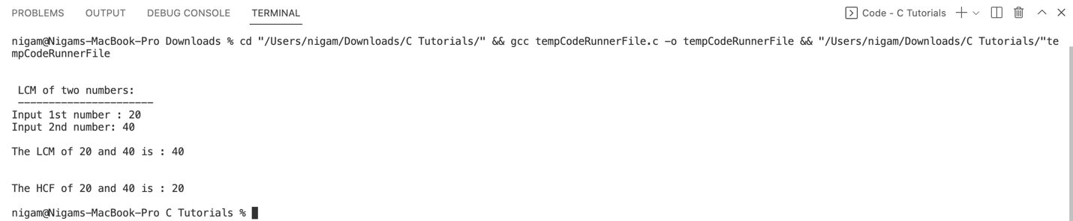

13.WAP to print the following patterns:

1 1 2 3 4 5 * 1

1 2 1 2 3 4 *** 2 3

1 2 3 1 2 3 ***** 4 5 6

1 2 3 4 1 2 ******* 7 8 9 10

1 2 3 4 5 1 ********* 11 12 13 14 15

1 2 3 4 5 4 3 2 1 5 4 3 2 1

1 2 3 4 3 2 1 5 4 3 2

1 2 3 2 1 5 4 3

1 2 1 5 4

1. 5

**Code:**

#include <stdio.h>

int main()

{

int row,column,n=5;

for (row=1;row<=n;row++)

{

for(column=1;column<=row;column++)

{

printf(" %d",column);

}

printf("\n");

}

return 0;

}

Output:

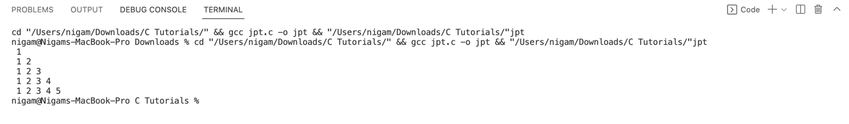

**Code:**

#include <stdio.h>

int main()

{

int row,column,n=5;

for (row=5;row>=1;row--)

{

for(column=1;column<=row;column++)

{

printf(" %d",column);

}

printf("\n");

}

return 0;

}

Output:

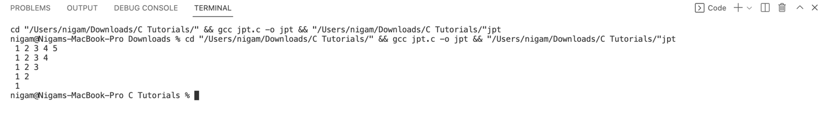

**Code:**

#include <stdio.h>

int main()

{

int row,star,space,n=5;

for(row=1;row<=n;row++)

{

for (space=1;space<=n-row;space++)

{

printf(" ");

}

for(star=1;star<=(2*row-1);star++)

{

printf("*");

}

printf("\n");

}

return 0;

}

Output:

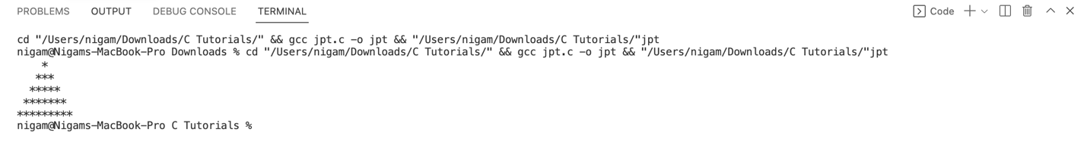

**Code:**

#include <stdio.h>

int main()

{

int row,column,sum=0,n=5;

for (row=1;row<=n;row++)

{

for(column=1;column<=row;column++)

{

sum=sum+1;

printf("%d ",sum);

}

printf("\n");

}

return 0;

}

Output:

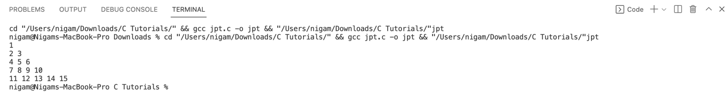

**Code:**

#include <stdio.h>

int main()

{

int row,column,i,n=5;

for (row=1;row<=n;row++)

{

for(column=1;column<=n-row+1;column++)

{

printf("%d",column);

}

for(column=n-row;column>=1;column--)

{

printf("%d",column);

}

printf("\n");

for (i=1;i<=row;i++)

{

printf(" ");

}

}

return 0;

}

Output:

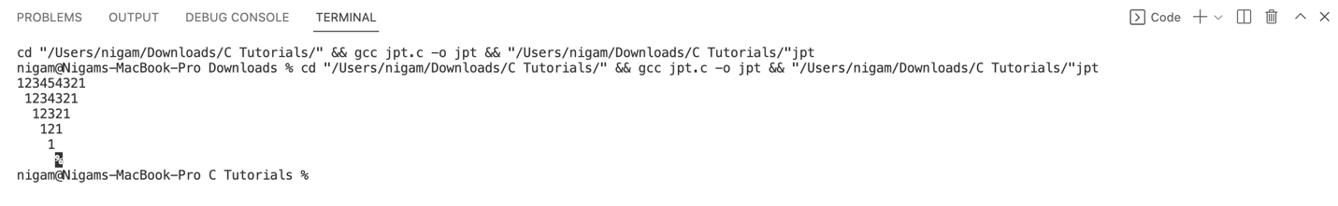

**Code:**

#include <stdio.h>

int main()

{

int row,column,n=5;

for (row=1;row<=n;row++)

{

for(column=5;column>=row;column--)

{

printf("%d",column);

}

printf("\n");

}

return 0;

}

Output:

